**DAILY ONLINE ACTIVITIES SUMMARY**

|  |  |  |  |  |  |  |  |
| --- | --- | --- | --- | --- | --- | --- | --- |
| **Date:** | **29/05/20** | | | | **Name:** | **Namratha C** | |
| **Sem & Sec** | **8th sem, A sec** | | | | **USN:** | **4AL16CS056** | |
| **Online Test Summary** | | | | | | | |
| **Subject** | | **BDA** | | | | | |
| **Max. Marks** | | **21** | | **Score** | | **30** | |
| **Certification Course Summary** | | | | | | | |
| **Course** | **Introduction to Ethical Hacking** | | | | | | |
| **Certificate Provider** | | | **Great Learning** | **Duration** | | | **254 mins** |
| **Coding Challenges** | | | | | | | |
| **Problem Statement: 1) Python program to check if it's prime number or not.**  **.** | | | | | | | |
| **Status: Completed** | | | | | | | |
| **Uploaded the report in Github** | | | | **Yes** | | | |
| **If yes Repository name** | | | | **CODES (Namrathasonu)** | | | |
| **Uploaded the report in slack** | | | | **Yes** | | | |

Online Test Details:

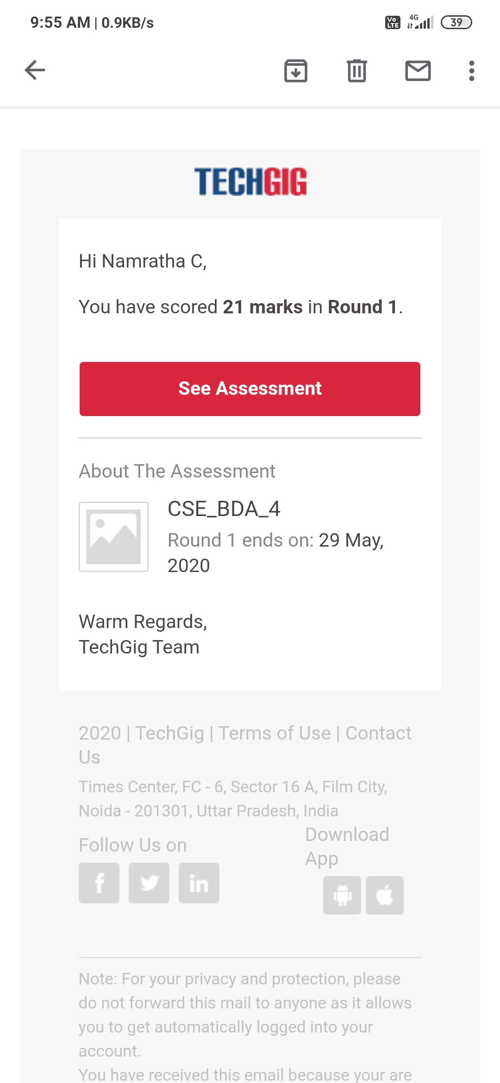

The test was on the subject Big Data Analytics.

Certification Course Details: **COMPLETED**

Coding Challenges Details:

1)

num =407

if num > 1:

for i in range(2,num):

if (num % i) == 0:

print(num,"is not a prime number")

print(i,"times",num//i,"is",num)

break

else:

print(num,"is a prime number")

else:

print(num,"is not a prime number")